Dr. Dudley Goodhead Selected to Receive Fifteenth Gray Medal

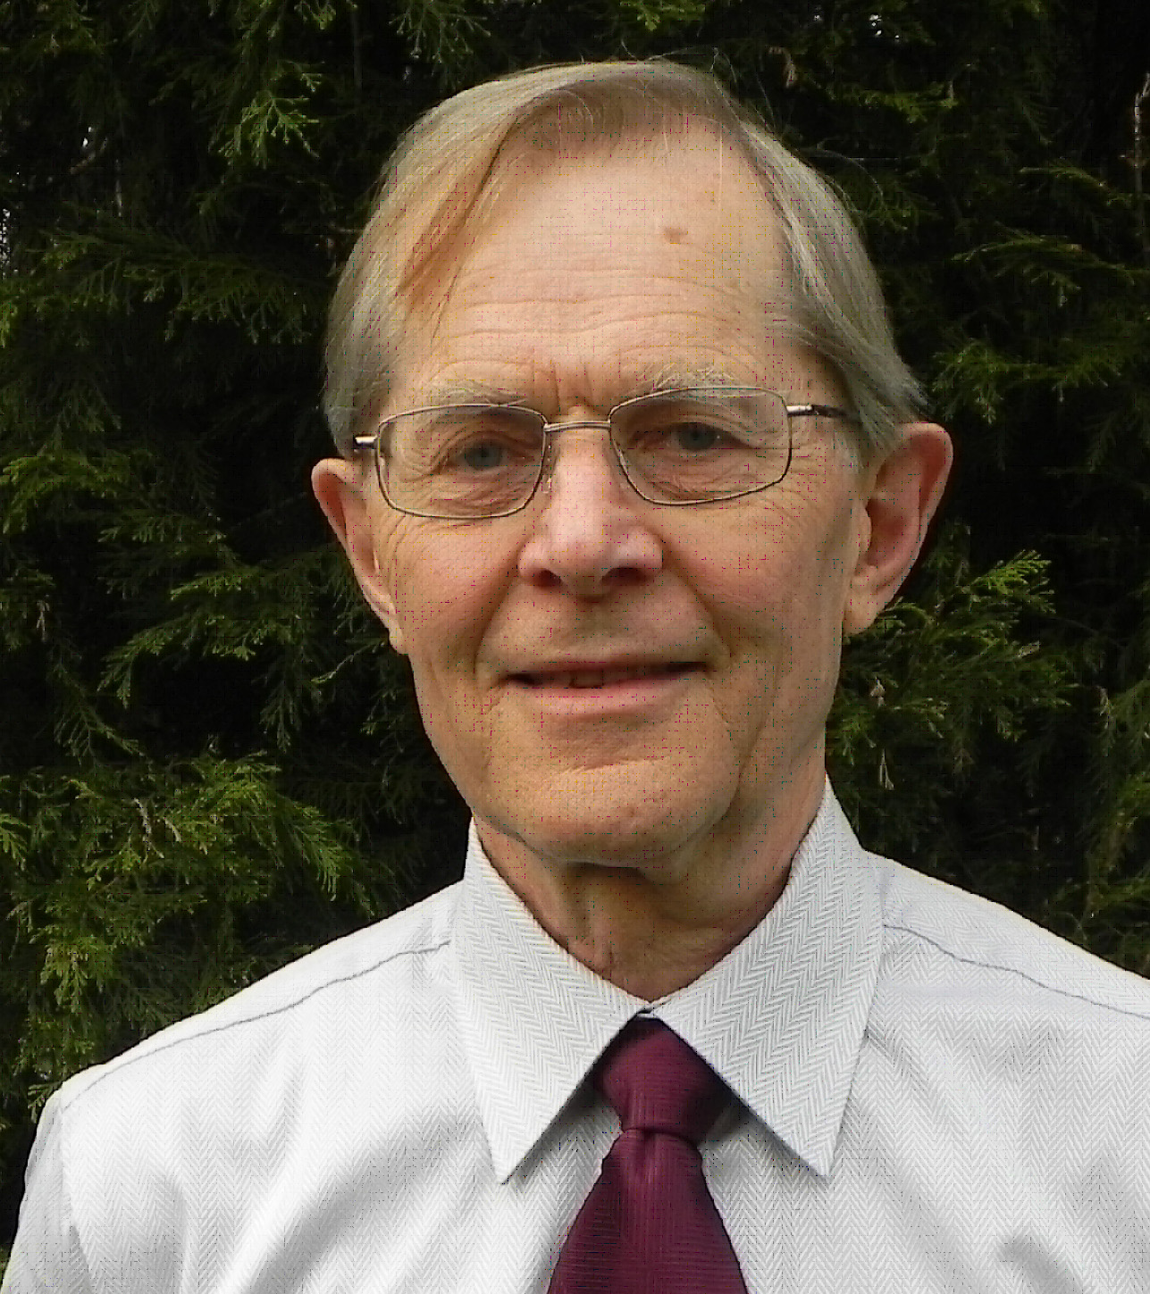
The ICRU is pleased to announce that the 15th Gray Medal will be presented to Professor Dudley Goodhead at the 14th International Congress of Radiation Research meeting to be held in Warsaw, Poland. The Award will be presented during a plenary session on 31 August 2011.

Dudley T Goodhead was Director of the Medical Research Council’s (MRC) Radiation and Genome Stability Unit at Harwell, UK, until his retirement in September 2003. The Unit carried out basic research on the relationship of genome stability to human health, including how the DNA may be damaged by radiation and other agents and how the cellular repair systems act to restore normality. He continues as a visitor at MRC Harwell and assists the European Commission’s research program as well as a number of agencies in the USA and UK. His personal research has been mainly on the biophysics of radiation effects with particular emphasis on microscopic features of radiation track structure at the atomic, molecular and cellular levels and their consequent radiobiological and health effects.

He was born and educated in South Africa. Thereafter he gained his D.Phil. at the University of Oxford (UK) in 1965 in particle physics and then went on to academic positions at the University of California (Los Angeles), St Bartholomew’s Hospital (London) and the University of Natal (Durban, South Africa). He joined the MRC Radiobiology Unit at Harwell in 1975.

Professor Goodhead has served on a variety of national and international committees on evaluation of radiation risks. These have included the Committee on Medical Aspects of Radiation in the Environment (COMARE) in the UK, the Biological Effects of Ionizing Radiation (BEIR-VI) radon-risk assessment in the USA, consultancies to the United Nations Scientific Committee on Effects of Atomic Radiation (UNSCEAR) and the International Atomic Energy Agency (IAEA), and Working Groups of the International Agency for Research on Cancer (IARC) on carcinogenic risk of gamma rays, neutrons and internally-deposited radionuclides, and the Royal Society (on risks from depleted uranium). He was chairman of the Committee Examining Radiation Risks of Internal Emitters (CERRIE) in the UK until its final report in October 2004. More recently, he acted as technical secretariat to the High Level and Expert Group on Low Dose Risk Research (HLEG) in Europe, which recommended the development of a Europe-wide platform for future research in radiation protection.

In June 2002, in the Queen’s birthday honours list, Professor Goodhead was awarded the Order of the British Empire (OBE) for services to medical research. He has been the recipient of various other awards, including the Weiss Medal (Association of Radiation Research, UK), Failla Medal (Radiation Research Society, USA), Douglas Lea Lecturer (Institute of Physics and Engineering in Medicine, UK), Bacq and Alexander Award (European Society of Radiation Biology), Honorary Fellowship of Society of Radiological Protection (UK) and Warren K Sinclair Lecturer (National Council on Radiation Protection and Measurements, USA).

